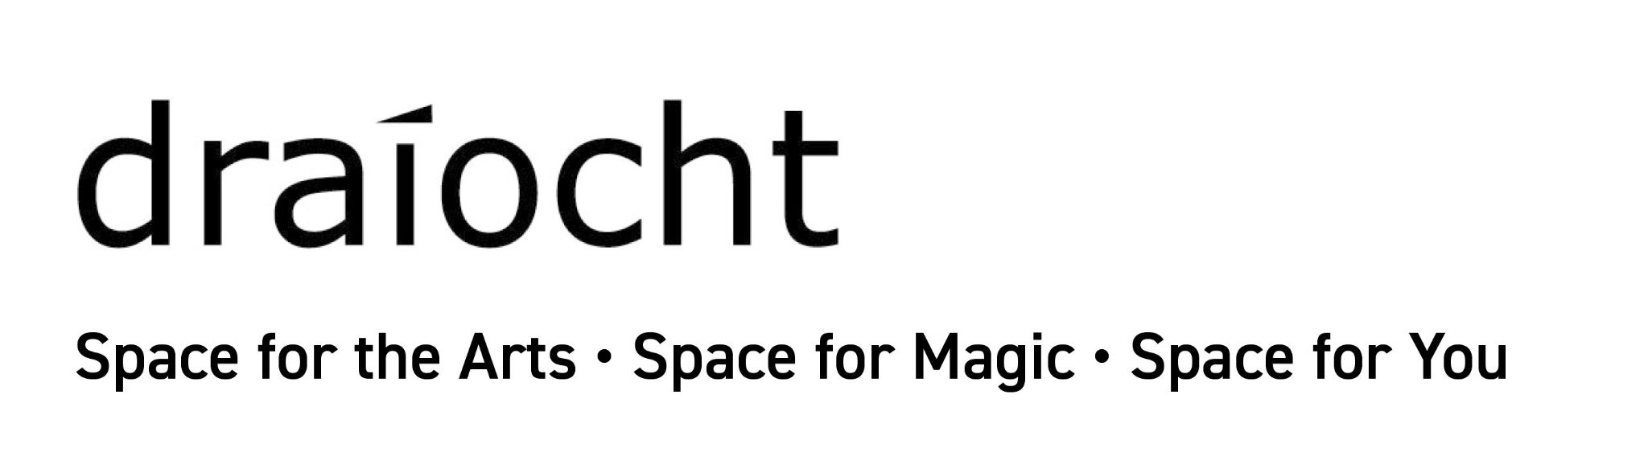
Draíocht Blanchardstown
Open Call for recent visual art graduates 2019, 2020, 2021
as part of Draíocht’s 21st Birthday Exhibition Programme
Exhibition dates: 02 March-30 April 2022
Closing date for submission: 31st December 2021
ENTRY FORM
All Fields In The Entry Form Below Must Be Filled In.
Incomplete Or Inaccurate Entry Forms Will Not Be Processed.
Please See Guidelines For Further Information.
Personal details
First Name | Surname
Address | Country
Mobile | Email
Website | Other social media

Details of Art College
Name of Art College | Name of Course
Level(s) achieved | Year of Graduation

Details of Practice
Biography (max 200 words)

Artist’s Statement (max 200 words)

Details of Artwork Submitted to include
Title:
Date of completion:
Medium (e.g. oil, print, photograph, bronze, video, performance):
Support (e.g. paper, canvas, plasma screen):
Unframed dimensions (height x width in cm):
Framed dimensions (height x width in cm):
Description of work (max 200 words):

Checklist | PLEASE TICK
Is your work display-ready as per Guidelines? | [ ] YES
Do you agree to send your video or audio file to draiocht21opensubmission@gmail.com using WeTransfer. The video or audio filename will include your full name | [ ] YES  [ ] NOT RELEVANT
I have read the rules and guidelines of this Open Call and agree to be bound by them. | [ ] YES
Please tick if the work is for sale.  Include price if the work is for sale | [ ] YES [ ] NO  PRICE €_____
All Fields In The Entry Form Must Be Filled In.
Incomplete Or Inaccurate Entry Forms Will Not Be Processed.
Please re-read the Guidelines for Further Information before sending your submission.
Please return this completed entry form in PDF format.
This Entry Form must be accompanied by Jpegs, Video or Audio files of the work.

Summary of Key Dates for Artists
15 November 2021 Open call announcement
31 December 2021 Closing date (stage 1 online submission)
27 January 2022 Shortlist Announced
31 January & 01 February 2022 Delivery of shortlisted works to Draíocht
09 & 10 February 2022 Collection of unselected artworks
11 February 2022 Announcement of selected works for Exhibition
02 March 2022 Exhibition opening
30 April 2022 Exhibition closing

Submissions to:
draiocht21opensubmission@gmail.com
by 5PM on Friday 31 December 2021

Draíocht is a registered charity, not for profit arts organisation, generously funded by Fingal County Council with additional funding provided by The Arts Council. | 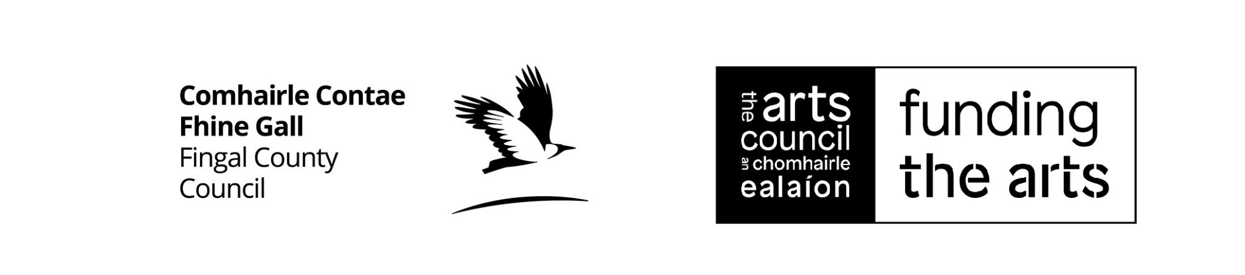 | Draíocht  The Blanchardstown Centre  Blanchardstown, Dublin 15,  D15 RYX6 www.draiocht.ie

